Kole Imports FBA Guidelines

Thank you for your interest in our products and services. We look forward to working with you and have prepared this guide as a way to help you get started. Below is an outline of the steps to take for setting up your account with us, and the process of building and submitting your orders online.
It is best to work directly with one of our sales reps for all FBA orders. They will help manage your order flow and ensure that there aren’t any unexpected delays along the way. If you do not yet have a sales rep you can call or email our friendly support team and they will put you in touch with one of our knowledgeable sales reps.
Please read this guide thoroughly as it covers the entire process and should answer any questions that you may have. Following the instructions here will avoid any unnecessary back and forth’s and ensure that your order gets processed and shipped as quickly as possible.

Step 1- Setting Up Your Account
Sign up for your free account at www.koleimports.com. During registration you will be asked to select a sales rep and you will see a dropdown menu with a list of names. Please select the appropriate rep, complete all other required information and save.
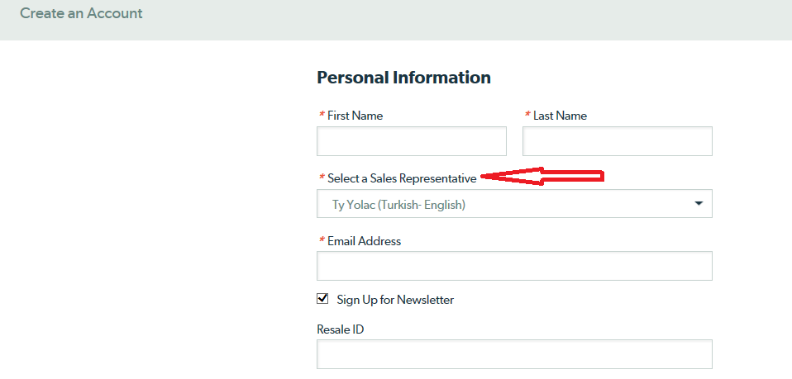

You should be signed in to your account prior to placing any orders. This will ensure that your rep will get a copy of the order when submitted and can begin the order prep once receiving your instructions.
Step 2- Finding the Items You Want to Sell
Start browsing through our site for product ideas. We have thousands of items to choose from and are getting new products every day! Our website has some great features to help you narrow down your search. You can search by category, subcategory, price ranges, current specials and more!
You can also speak to your rep about product ideas and suggestions but keep in mind that ultimately the decision is yours. Ultimately, the presentation of the item (titles, descriptions, images etc.) goes a long way in marketing and selling your product.
What we can also recommend is that unless you know a certain item will do well; try to go with a smaller quantity of more items rather than a large quantity of one or two items. This will keep you from putting all of your eggs in one basket and increase your chances of finding some hot items. We would recommend starting with at least a case of each item you are purchasing.

Step 3- Product Setup and Conversion to FBA
Set up the items on your Amazon Seller Central account and convert the inventory to FBA. This process is done entirely through Amazon and unfortunately we can’t offer much assistance on that end. If you have problems it would be best to contact Amazon for support.

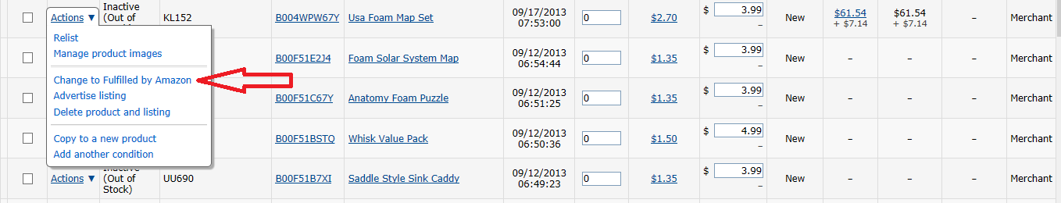

When converting the inventory to FBA you will be asked for information on the size and weight of the boxes being sent in. For this info you will go back to our website. Each item page will have a Specifications tab where you will find the case dimensions and per piece weight.
For any quantity below the case quantity, or if you are combining multiple items into one box, you will have to estimate a shipping box size. It’s best to go off the case dimensions of the largest item in the shipment. You will then calculate the weight of the package by simply multiplying the per piece weight by the quantity being shipped. Please also note that if you are shipping in full case pack quantities, they cannot be combined into larger boxes. Each full case pack will ship in it’s own box.
The case estimate along with the exact weight will give you a fairly accurate shipping rate and label. Any discrepancies will be adjusted when UPS scans the label and it would be credited or debited through your Seller Central account.
When you input this info on Amazon you will be able to generate the prepaid UPS shipping labels that you will send to us. The ship from address you’ll use is 24600 Main St, Carson, CA 90745. We cannot prep and pack your order until we first receive your shipping labels and order instructions.
Once the labels are created you should save these shipping labels as a PDF file onto your desktop. If you also choose to generate the Amazon FNSKU labels, please also save those as a PDF file to your desktop. The shipping label PDFs should be renamed with the corresponding Amazon shipment ID, ex. FBA20YBHKX.

Step 4- Submitting Your Order
This is when you’ll start building the order on our website. Go ahead and add all the items that you’re ordering to the shopping cart. You can submit one order and we can break that up into multiple ship-to locations or you can submit separate orders going to the different fulfillment centers. Splitting up the orders will expedite the processing on our end and allow us to get your order out faster.
There are a few special selections to make when submitting your order to classify it as an FBA order, one being the ship method and the other being the optional prep work we offer.
When you are ready to checkout you will click on the green Checkout button in your shopping cart. That will take you to your Order Summary page where you will click on the green Proceed to Checkout button.
On this last checkout page you will see three steps- Billing Address, Shipping Method and Payment Method.

- Billing Address
Make sure that your billing address is entered exactly as it appears on your credit card or on your PayPal account. Our payment processor is very picky and if these addresses do not match up then the order payment may not go through and cause delays with your order.
For the shipping address you can enter your billing address or one of the Amazon warehouse addresses. This ship to address field is required but the address you provide is not important because your shipments will always go to the addresses that are on your prepaid shipping labels.

- Shipping Method
We highly recommend using Amazon’s partnered UPS account for shipping purposes, as it will be a much better rate than our FedEx account. To get these labels please refer to the instructions in Step 3 of this guide.
You will then click on the “Shipping Label – Customer to Send Prepaid Shipping Labels” shown below-
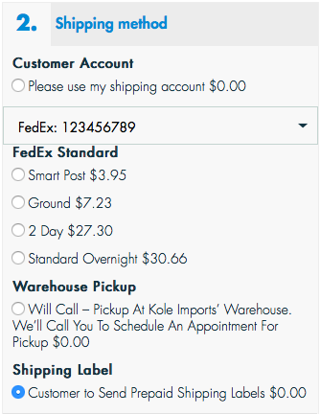
Clicking this Shipping Label option will open another selection for you to pay for your optional prep services. The breakdown and explanation of these services is covered in the Branding and Labeling section of this guide below.

- Payment Method
Once your shipping method is set and optional prep fees added to order, you are ready to pay for your order. You can choose from an existing card in your account, add a new card or pay with PayPal.

When the above steps are completed, your order will be finalized and you will receive a confirmation email with your order number. Your sales rep will also receive a copy and wait for your instructions to proceed.

Step 5- Sending the Order Info and Labels
At this point you’ll need to send over your order instructions and shipping labels. The email should be sent directly to your sales rep, sending it to one of our general mailboxes may cause delays in order processing.
All order instructions and necessary attachments should be sent over in one email. You should forward the copy of your order confirmation with the above information so that your rep knows which order it belongs to. The subject of the email should read “Instructions for order 1000…” and should contain all relevant info for that order only.
The shipping label attachments should be renamed with the corresponding Amazon shipment ID. See example below:

In the body of the email we’ll need the breakdown of the shipping locations, items and quantities going to each location. Please include the full address of the Amazon fulfillment center, the list of items with our SKU numbers and the quantities going to each location. Again, this needs to be in the BODY of the email, not sent as an attachment. This info should be in the exact format in the example below:

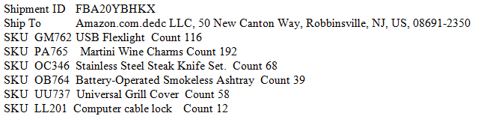

If your instructions are not in the body of the email and not in the format shown above then your rep may have to contact you for further clarification or request that you send in the correct format.

Optional Prep Services

Kole Imports offers a selection of optional prep services, which can be used to create a more unique product for you. Our in house services include labeling, bundling and packaging replacement. We can also offer further customization through our manufacturers overseas.
All in house prep services should be paid for when checking out on our website. You will see the option pop up once you select the prepaid shipping label covered in Step 4 above. You will set the quantity for the desired service and add to your order, see example below.

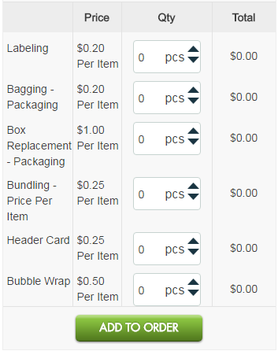

Labeling
Our most basic service is labeling where we can apply a new FNSKU barcode and/or logo sticker onto the existing packaging of your product. A new FNSKU will allow you to create a new product page for your item where you will have total control of the title, description, images etc. You can also list the item with the existing UPC on the package in which case you will have to sell on the existing product page where you may or may not have control over the product information.
This service is offered for $0.15 per label and we will need you to include these attachments along with your order instructions. If sending FNSKU barcodes they should be in the standard format you download from your Seller Central account. These should be formatted to print on 2 5/8” x 1” address labels that come 30 per sheet. If sending a logo it should be saved as a jpeg or png file and formatted to print on a 1.5” x 1.5” square sticker.
If you are looking for a logo sticker of a different size or shape then you would have to get those made off site and physically mailed to us where we would then apply for $0.15 each.
Example
If you are ordering 24 pieces of an item and need just FNSKU barcodes applied, you would put 24 pieces under the Labeling quantity. If you ordered the same 24 pieces and wanted both an FNSKU and logo applied, you would put 48 pieces under the labeling quantity.

Bagging
Any of our items can be poly bagged for an additional $0.15 per unit. This is recommended for any item that is exposed, as Amazon generally does not like any part of a product to roll exposed on their conveyor belts. Certain size poly bags will also require a suffocation warning which can be applied for an additional $0.15 per unit.
Example
If you are ordering 24 pcs of an item and just want poly bagging, you will enter 24 under the Bagging quantity. If you order the same 24 pcs and want them bagged with a suffocation warning and FNSKU barcode, you will enter 24 under the Bagging quantity and 48 under the Labeling quantity.

Box Replacement
We cannot product new packaging onsite but you are welcome to have this produced offsite and mailed to us for prep. We will take the item out of it’s existing packaging and replace with the new packaging you provide. We would recommend that all information like your logo and barcode be printed on this packaging so that you do not incur any additional prep fees.
Example
If you are ordering 24 pieces of an item and would like us to replace the current packaging with your own, you will enter a quantity of 24 under the Box Replacement quantity.

Bundling
Any number of items can be combined together to create a new, unique product for you. These would be combined and placed inside a polybag with a FNSKU on the outside specifying the contents of the bundle.

This service is offered at $0.15 per item in the bundle. The fee includes the cost of the poly bag and one label (FNSKU) on the bag. Additional labels would come at an added $0.15 each.

Example

If you are ordering 24 pieces of two different items and want to bundle them
together, you will enter a quantity of 48 under the Bundling quantity. If you are
ordering the same 24 pcs of two items and want them bundling together and want
a warning sticker or logo sticker on the bag you will enter a quantity of 48 for
bundling and a quantity of 24 for Labeling.

Header Card

A header card is a type of packaging used on items that come in bags. There are many items like this in our catalog, an example would be an item like CC003 on our
website.

If you a e looking for this type of prep then you will have to get the header cards made offsite and mailed to us. Again, we would advise getting all necessary info printed on the cards to avoid any additional prep fees.

Example

If you are ordering 24 pcs of an item and would like to replace the existing header
Card, you will enter a quantity of 24 under the Header Card option. If you are ordering 24 pcs of an item and would like to bag it and add a header, you will enter a quantity of 24 under the Bagging option and 24 under the Header Card option.

Please note that any of the above prep options will add to the processing time of your order. Any order shipping as-is with no prep needed will generally ship out within 48 hours. Adding any prep means that your order will take from 3-7 business days to get ready. The turnaround time will depend on the size of your order and the number of other orders being prepped at that time. Please be patient during this time.

Custom Sourcing

Through our manufactures we can offer more extensive customization, from packaging to actual product modifications. This is best used for items that are already in our catalog but we can also look for items that are outside of our current network. We will need as much information as possible regarding the specifications of the item and the desired packaging.

Our manufacturer will provide us with an MOQ and price, which includes delivery to our warehouse. We can also provide a sample of the product prior to going into production if needed.

The turnaround time for custom work is generally 75-90 days but can be more or less depending on the manufacturer. We require a 50% deposit up front with the balance due upon delivery of goods to our warehouse.

This guide covers all the basics of our FBA services, how to submit your orders on our website, pay for your prep services and how to get us all the required instructions so that we can get started. Please read it thoroughly as it should answer any questions you may have. If you have any further questions or if anything is not clear, please reach out directly to your sales rep who will be happy to assist.

We thank you for choosing Kole Imports FBA Services and look forward to working with you!

